A Project Report On

**Food Restaurant Website**

Name: Shriya Suryawanshi

Type of Project: Web Development

Technology Used: HTML5, CSS3 & JAVASCRIPT

Developer Tool Used: VS Code

Date of Submission: 26-10-2024

**1. Overview:**

Welcome to Shriya Restro's website, where culinary delights come to life! Explore our diverse menu, designed to tantalize your taste buds with a variety of dishes crafted with passion and expertise. Each item is thoughtfully curated to offer a unique dining experience, whether you're here for a quick bite or a full-course meal.

Immerse yourself in the vibrant world of food through our user-friendly interface, which allows you to navigate seamlessly between our menu, services, and contact information. Our goal is to provide a memorable online experience that reflects our commitment to quality and customer satisfaction.

**2. Objectives**:

* **Showcase Culinary Offerings:** Highlight the variety and quality of dishes available, allowing customers to appreciate the artistry of our cuisine.
* **Facilitate Easy Ordering:** Enable customers to place orders efficiently through our website, providing a convenient dining experience.
* **Enhance Customer Engagement:** Foster interaction with our customers through a visually appealing layout and engaging content, encouraging feedback and connection.
* **Promote Brand Awareness:** Build a strong online presence that reflects our brand values and the unique atmosphere of our restaurant.
* **Streamline Communication:** Provide clear contact details and a simple way for customers to reach out for inquiries or reservations.
* **Encourage Social Sharing:** Make it easy for customers to share their dining experiences on social media, increasing our visibility and reach.
* **Maintain Professionalism:** Uphold a polished and professional online presence that resonates with our target audience.

**3. Key Features:**

**Home:**

* Welcome Banner: A visually appealing introduction to the restaurant's ambiance and offerings.
* Featured Dishes: Highlight top menu items or specials to entice visitors.
* Quick Navigation: Easy links to Menu, About, Location, and Contact sections.
* Prominent buttons encouraging visitors to explore the menu or place an order.
* Categorized Items: Organize dishes by categories
* Modal Functionality: Allow users to view item details and place orders in an intuitive modal window.
* **About:**
* Contact Information: Provide easy access to phone numbers, email, and social media links.
* Contact Form: A simple form for inquiries, feedback, or reservation requests.
* Footer:
  + Social Links: Connect with customers through various social media platforms.
  + Useful Links: Quick access to important sections of the website.

**Output Screens :**

**Home page**

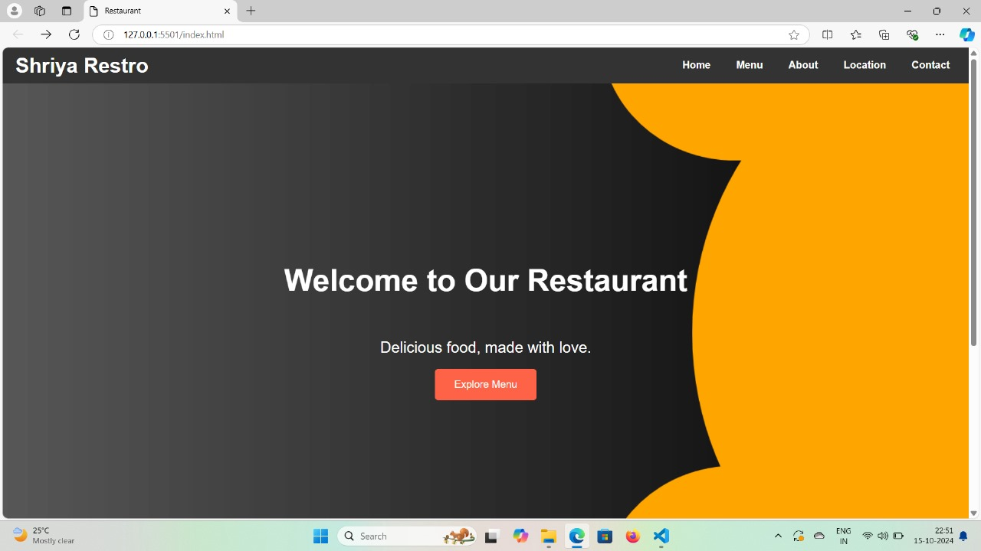

**About us:**

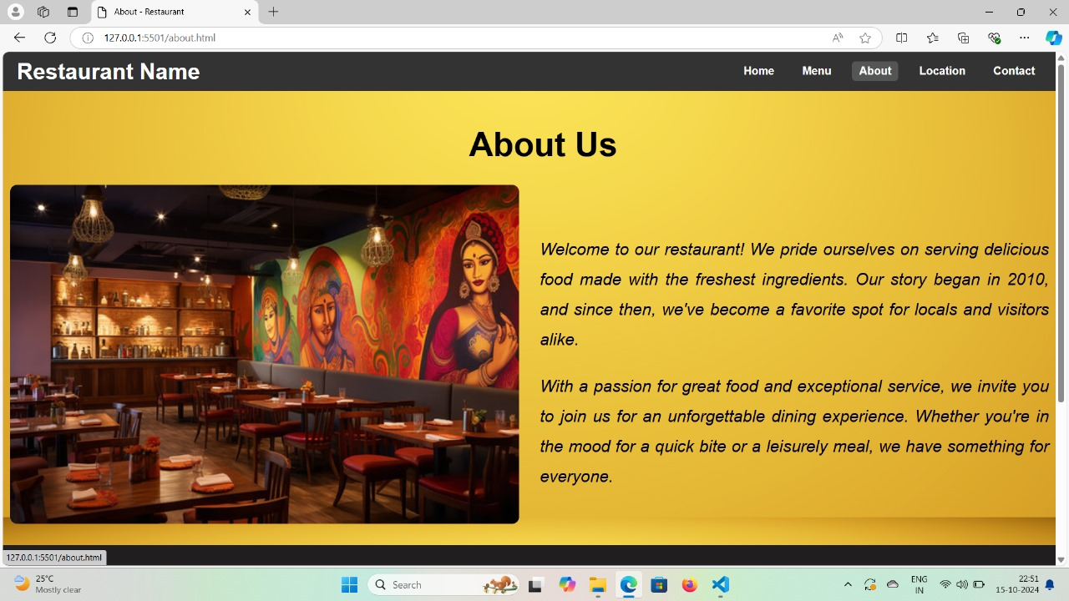

**Our Menu :**

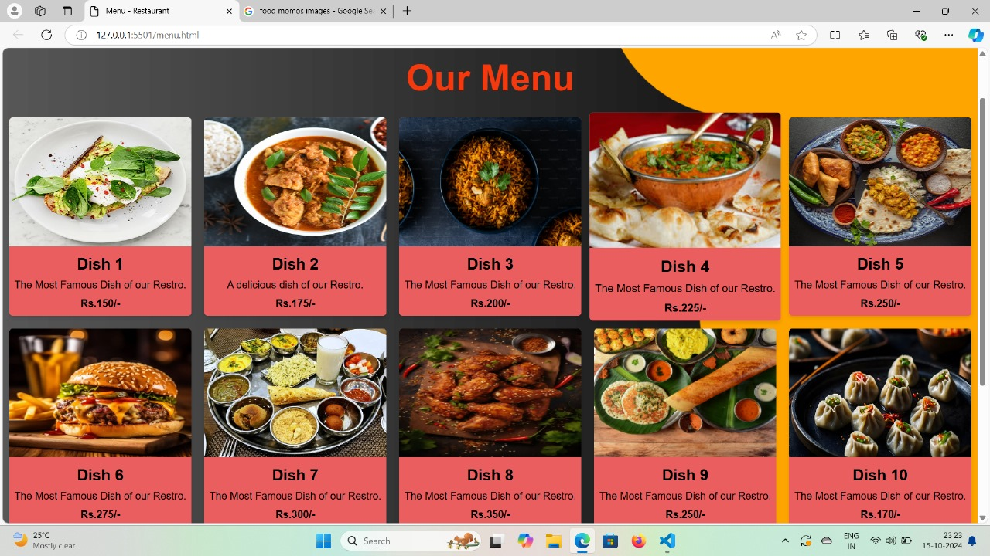

**Location page:**

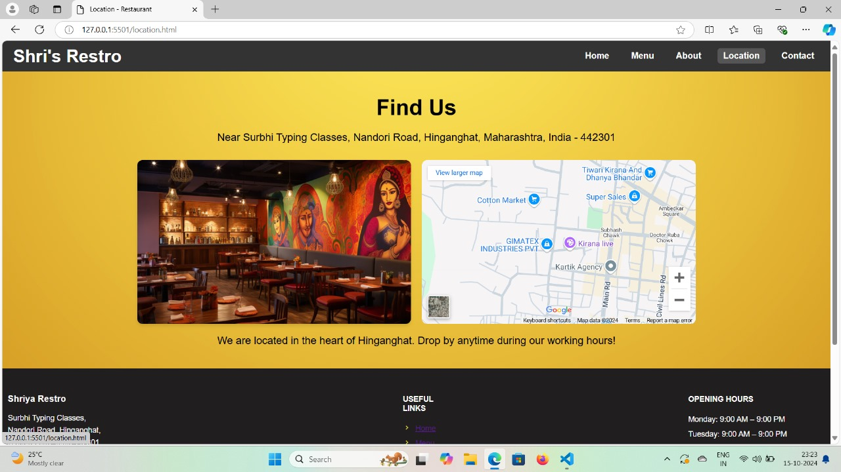

**Contact page:**

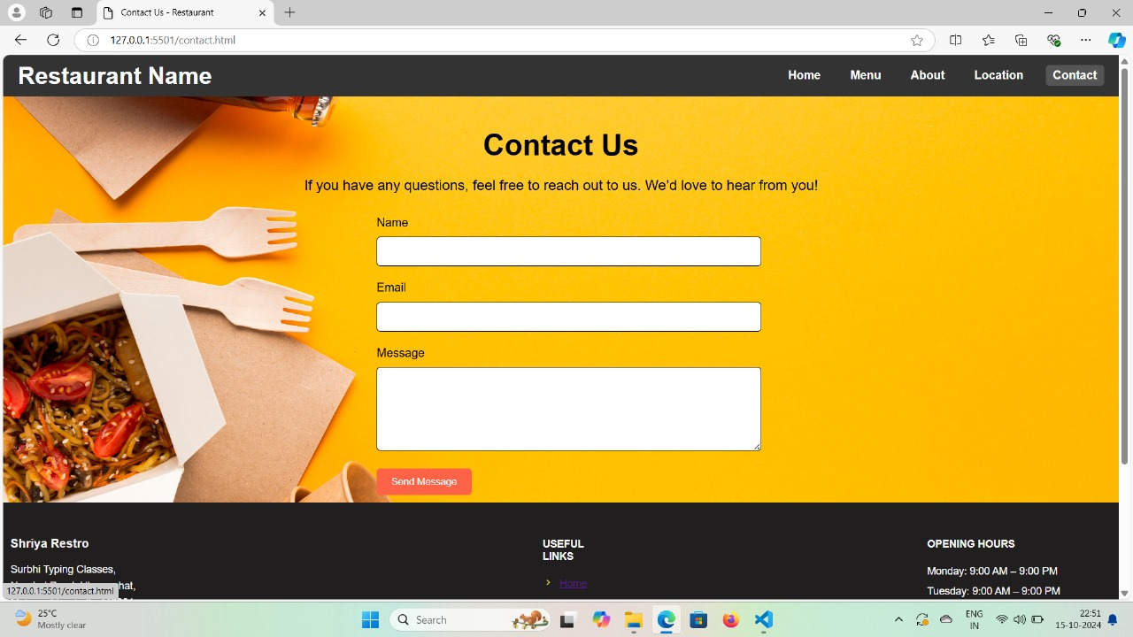

**THANK YOU….!**